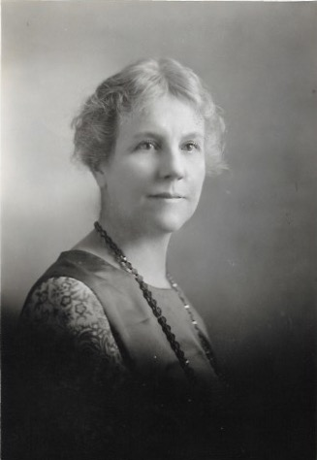
  - Calling All Colorado
  - American Baptist Women Students
- Are you an active member of your church?
- Will you graduate with a high school
diploma?
- Will you be a full-time undergraduate at an
accredited university, college or community
college?

  - If you answered yes to these questions, apply for the . . . . . .

Jane Loring Jones Scholarship!

Dr. Jamie D. Johnson, Chair
jljscholarship@gmail.com
To apply for the Jane Loring Jones application, click on the following link http://abcrm.org/ministries/abwm/colorado
Application will be available March 1 and due May 3.

